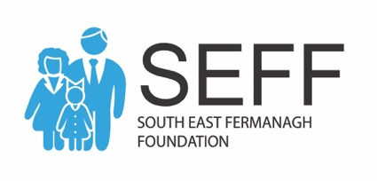

South East Fermanagh Foundation

EQUAL OPPORTUNITIES MONITORING

APPLICANT REF NO……

NON-COMPLETION OF THIS SECTION WILL RESULT
IN YOUR APPLICATION BEING REJECTED.
PLEASE SUBMIT IN A SEPARATE SEALED ENVELOPE.

SEFF is committed to equality of opportunity for all job applicants regardless of individual differences and therefore selects staff solely on the basis of merit.

Monitoring is undertaken to ensure SEFF’s Equal Opportunities Policy is effective. We need your information for this and ask you to complete the following questionnaire by ticking the appropriate boxes.

- SEX Male Female

- MARITAL STATUS Single Married Other

- Do you consider yourself Yes No
to have a disability?

Do you require any adjust- Yes No

ment in order to access
employment

- I am a member of the Protestant Community

I am a member of the Roman Catholic Community

I am neither a member of the Protestant nor the Roman Catholic Community

- AGE RANGE
Please tick appropriate box

18-25 46-55

26-35 56-65 Date of Birth

  - 65+

- ETHNIC MONITORING
Please tick one or more boxes as appropriate:

01 Caribbean |  | 02 African |  | 03 Chinese |  | 04 White
05 Bangladesh |  | 06 Pakistani |  | 07 Indian |  | 08 Black
09 Irish Traveller |  | 10 Other

IT IS AN OFFENCE TO KNOWINGLY GIVE FALSE
INFORMATION FOR MONITORING PURPOSES

This section of the application form will be stored in a confidential manner until information has been extracted for equal opportunities monitoring purposes, and will then be destroyed.

Monitoring involves the use of statistical summaries of information in which the identities of individuals do not appear. Your individual information must also be released to statutory bodies if requested.

