Senator John Eccles Nixon Barnhill

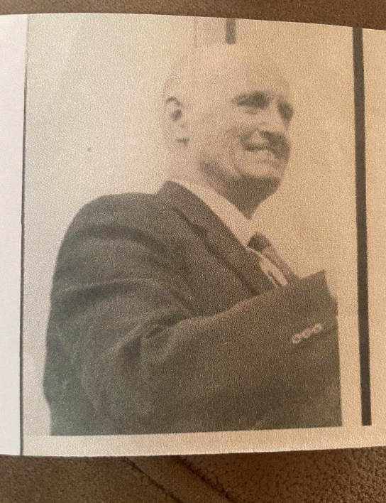
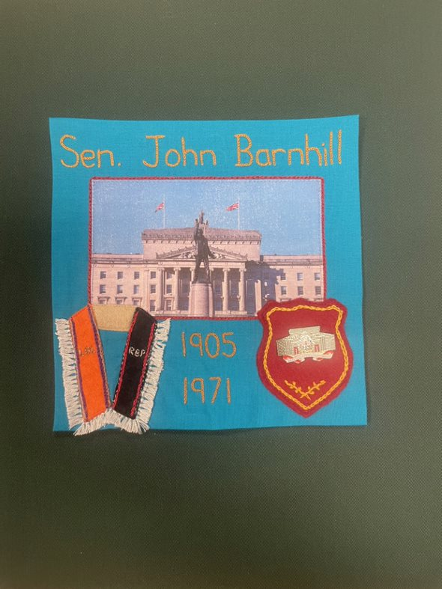
.

Civilian – Senator in the Parliament of Northern Ireland
11th April 1905 – 12th December 1971
John was educated at Prior School, Lifford, Co. Donegal, and Campbell College, Belfast. On leaving Campbell College, Barnhill began a business career with the agricultural machinery firm known as William Thompson & Co. Ltd and became managing director.
Coming from a farming background he also served for many years as honorary treasurer of the North-West of Ireland Agricultural Society.
John Barnhill was a member of the Ulster Unionist Party and was elected to the Senate in the Parliament of Northern Ireland in 1962.
Senator Barnhill was murdered on 12th December 1971 in a bomb attack which also destroyed his home, his wife was also there but had been ordered out of the home and reached her neighbours when the bomb went off. The Official IRA claimed responsibility.
John was a member of the Loyal Orange Lodge 251 and Royal Black Preceptory 91 as well as Mitchelbourne Club Apprentice Boys.

